Industrial Monitoring of Humidity Temperature Sensor and Water Level Using Raspberry Pi

:

Component Pin Connections
BME280 (I2C)
VCC 3.3V (Pin 1)
GND GND (Pin 6)
SDA GPIO 2 (Pin 3)
SCL GPIO 3 (Pin 5)
HC-SR04 VCC
5V (Pin 2)
GND GND (Pin 14)
TRIG GPIO 23 (Pin 16)
ECHO GPIO 24 (Pin 18) (with voltage divider)

YF-S201
VCC (Red) 5V (Pin 4)
GND (Black) GND (Pin 9)
OUT (Yellow) GPIO 17 (Pin 11)

Relay Module
VCC 5V (Pin 2)
GND GND (Pin 6)
IN GPIO 27 (Pin 13)

Buzzer
Signal (+) GPIO 22 (Pin 15)
GND (-) GND (Pin 9)

16x2 LCD / OLED (I2C)
VCC 5V (Pin 2)
GND GND (Pin 6)
SDA GPIO 2 (Pin 3) (shared)
SCL GPIO 3 (Pin 5) (shared)

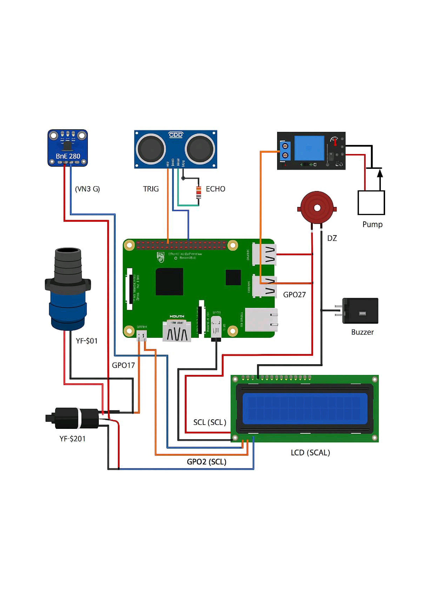
PROGRAMING

import RPi.GPIO as GPIO
import smbus2
import bme280
import time
import csv
import datetime
import pyttsx3
import requests
import sqlite3
from RPLCD.i2c import CharLCD # Added for LCD

# Initialize text-to-speech engine
tts = pyttsx3.init()

# GPIO pin setup
TRIG = 23
ECHO = 24
FLOW_SENSOR = 17
RELAY = 27
BUZZER = 22
TANK_HEIGHT_CM = 100
I2C_PORT = 1
BME280_ADDRESS = 0x76

# GPIO setup
GPIO.setmode(GPIO.BCM)
GPIO.setup(TRIG, GPIO.OUT)
GPIO.setup(ECHO, GPIO.IN)
GPIO.setup(FLOW_SENSOR, GPIO.IN, pull_up_down=GPIO.PUD_UP)
GPIO.setup(RELAY, GPIO.OUT)
GPIO.setup(BUZZER, GPIO.OUT)
GPIO.output(RELAY, GPIO.HIGH) # Pump initially off
GPIO.output(BUZZER, GPIO.LOW)

pulse_count = 0

def count_pulse(channel):
global pulse_count
pulse_count += 1

GPIO.add_event_detect(FLOW_SENSOR, GPIO.FALLING, callback=count_pulse)

# BME280 setup
bus = smbus2.SMBus(I2C_PORT)
calibration_params = bme280.load_calibration_params(bus, BME280_ADDRESS)

# LCD setup
lcd = CharLCD('PCF8574', 0x27) # Adjust I2C address if needed
lcd.clear()
lcd.write_string("Smart Monitor Ready")
time.sleep(2)

def read_distance_cm(timeout=0.03):
GPIO.output(TRIG, False)
time.sleep(0.05)
GPIO.output(TRIG, True)
time.sleep(0.00001)
GPIO.output(TRIG, False)

pulse_start = time.time()
timeout_start = pulse_start

while GPIO.input(ECHO) == 0:
pulse_start = time.time()
if pulse_start - timeout_start > timeout:
return None

pulse_end = time.time()
timeout_start = pulse_end

while GPIO.input(ECHO) == 1:
pulse_end = time.time()
if pulse_end - timeout_start > timeout:
return None

duration = pulse_end - pulse_start
return round(duration * 17150, 2)

def read_bme280():
data = bme280.sample(bus, BME280_ADDRESS, calibration_params)
return data.temperature, data.humidity, data.pressure

def send_telegram_alert(message):
bot_token = 'YOUR_BOT_TOKEN'
chat_id = 'YOUR_CHAT_ID'
url = f'https://api.telegram.org/bot{bot_token}/sendMessage'
payload = {'chat_id': chat_id, 'text': message}
requests.post(url, data=payload)

def send_email_alert(subject, message):
pass

def send_whatsapp_alert(message):
pass

def log_to_db(flow_rate, water_level, temp, humidity, pressure):
conn = sqlite3.connect("sensordata.db")
cursor = conn.cursor()
cursor.execute('''CREATE TABLE IF NOT EXISTS logs (
timestamp DATETIME,
flow_rate REAL,
water_level REAL,
temperature REAL,
humidity REAL,
pressure REAL
)''')
cursor.execute("INSERT INTO logs VALUES (datetime('now'), ?, ?, ?, ?, ?)",
(flow_rate, water_level, temp, humidity, pressure))
conn.commit()
conn.close()

try:
print("Smart Monitoring System Started...")
while True:
pulse_count = 0
time.sleep(1)
flow_rate = pulse_count / 7.5

temp, humidity, pressure = read_bme280()
distance = read_distance_cm()
if distance is None:
print("Ultrasonic timeout")
continue

water_level = max(0, min(100, 100 - (distance / TANK_HEIGHT_CM * 100)))

print(f"Flow Rate: {flow_rate:.2f} L/min")
print(f"Water Level: {water_level:.1f} %")
print(f"Temp: {temp:.2f} °C | Humidity: {humidity:.2f}% | Pressure: {pressure:.2f} hPa")

lcd.clear()
lcd.write_string(f"Temp:{temp:.1f}C\nHumidity:{humidity:.1f}%")
time.sleep(2)
lcd.clear()
lcd.write_string(f"Water:{water_level:.1f}%\nFlow:{flow_rate:.2f}L/m")

if flow_rate > 0 and water_level < 20:
msg = "Leakage Alert: Water is flowing but tank level is low."
print(f"[!] {msg}")
tts.say(msg)
tts.runAndWait()
GPIO.output(BUZZER, GPIO.HIGH)
send_telegram_alert(msg)
send_email_alert("Leak Detected", msg)
send_whatsapp_alert(msg)
elif flow_rate == 0 and water_level < 10:
msg = "Dry Alert: Tank is empty and no water flow."
print(f"[!] {msg}")
tts.say(msg)
tts.runAndWait()
GPIO.output(BUZZER, GPIO.HIGH)
send_telegram_alert(msg)
send_email_alert("Dry Tank Alert", msg)
send_whatsapp_alert(msg)
else:
GPIO.output(BUZZER, GPIO.LOW)

if water_level > 90:
GPIO.output(RELAY, GPIO.HIGH) # turn OFF pump
elif water_level < 20 and flow_rate > 0:
GPIO.output(RELAY, GPIO.LOW) # turn ON pump

log_to_db(flow_rate, water_level, temp, humidity, pressure)

except KeyboardInterrupt:
print("Exiting...")
GPIO.cleanup()

SAMPLE OUT[PUT
Smart Monitoring System Started...
Flow Rate: 1.65 L/min
Water Level: 76.8 %
Temp: 28.40 º c I Humidity: 61.80% | Pressure: 1013.05 hPa
LCD:
Temp:28.4C Humidity:61.8% —Y (waits 2 seconds)
Flow:1.65L/m
Flow Rate: 1.80 L/min
Water Level: 18.3 %
Temp: 28.42 º c I Humidity: 62.10% | Pressure: 1013.18 hPa > Leakage Alert: Water is flowing but tank level is low.
> Voice Alert Triggered > Buzzer ON > Telegram Alert Sent > Email Sent (simulated)
> WhatsApp Alert Triggered
LCD:
Temp:28.4C
Humidity:62.1%
Flow:1.80L/m
Flow Rate: 0.00 L/min
Water Level: 9.5 %
Temp: 28.38 º c I Humidity: 61.70% | Pressure: 1013.00 hPa
[!] Dry Alert: Tank is empty and no water flow.
> Voice Alert Triggered > Buzzer ON > Telegram Alert Sent > Email Sent
> WhatsApp Alert Triggered
LCD:
Temp:28.4C
Humidity:61.7%
Flow:O.OOL/m
Flow Rate: 2.05 L/min
Water Level: 92.0 % Pump turned OFF via Relay (GPIO 27)
Flow Rate: 1.35 L/min
Water Level: 14.2 %
Pump turned ON via Relay (GPIO 27)

DATABASE

Timestamp Flow Rate Water Level Temperature Humidity Pressure

2025-06-23 | 1.65 | 76.8 | 28.40 | 61.80 | 1013.05
2025-06-23 | 1.80 | 18.3 | 28.42 | 62.10 | 1013.18
2025-06 | 11 0.00 | 9.5 | 28.38 | 61.70 | 1013.00
2025-06-23 | 2.05 | 92.0 | 28.45 | 61.90 | 1013.25
2025-06-23 | 1.35 | 14.2 | 28.39 | 61.75 | 1013.10

Smart Monitoring and Control of Pressure and Power in Toyota Airjet Loom using Arduino

Connection details

Ardiuno UNO Configuration

Component | Function | Arduino Pin
MPX5700AP Pressure Sensor | Analog Pressure Input | A0
PZEM-004T | Power Monitoring (Serial UART) | D2 (RX), D3 (TX)
16x2 I2C LCD | Display | A4 (SDA), A5 (SCL)
Relay Module | Loom Motor ON/OFF Control | D5
Buzzer | Audio Alert | D6
LED | Visual Alert | D7
Bluetooth Module (HC-05) | Wireless Monitoring | D10 (TX), D11 (RX)*
Wi-Fi Module (ESP8266) | Cloud Storage (optional) | TX → D8, RX → D9 (via voltage divider)
Power Supply | 12V Adapter or USB | VIN or USB

MPX5700AP

Pin on MPX5700AP | Connects to
VCC | 5V on Arduino
GND | GND on Arduino
Output (Vo) | A0 on Arduino

PZEM pin configuratio

PZEM Pin | Arduino Pin | Notes
TX | D2 (RX) | Use SoftwareSerial
RX | D3 (TX)
VCC | External 5V | Shared with sensor/buzzer
GND | Arduino GND | Common Ground
Current Clamp | AC line | Clamp on motor wire
Voltage Line | AC Line | Connect Live & Neutral as per manual

LCD pin configuration

LCD Pin | Arduino Pin
SDA | A4
SCL | A5
VCC | 5V
GND | GND

Relay pin Configuration

Relay Pin | Arduino Pin | Description
IN | D5 | Control signal to toggle relay
VCC | 5V | Power for relay
GND | GND | Common ground
NO/NC/COM | Motor Line | Connect motor AC line through it

Buzzer Configuration

Device | Arduino Pin | Notes
Buzzer | D6 | 5V active buzzer
LED | D7 | 220Ω resistor in series

Bluethooth module

HC-05 Pin | Arduino Pin | Notes
VCC | 5V | Power
GND | GND | Common Ground
TXD | D10 (Arduino RX) | Can go directly
RXD | D11 via divider | Use voltage divider (5V → 3.3V)

HC-05 Configuration

HC-05 Pin | Arduino Pin | Notes
VCC | 5V | Power
GND | GND | Common Ground
TXD | D10 (Arduino RX) | Can go directly
RXD | D11 via divider | Use voltage divider (5V → 3.3V)

ESP8266 Configuration

ESP8266 Pin | Arduino Pin | Notes
VCC | 3.3V | Do not connect to 5V!
GND | GND | Common ground
TX | D8 (Arduino RX)
RX | D9 (Arduino TX) via divider | 5V → 3.3V via divider
CH_PD/EN | 3.3V | Pull-up resistor may be needed

Program
// Smart Monitoring and Control of Pressure and Power in Toyota Airjet Loom
// Using Arduino UNO, MPX5700AP, PZEM-004T, LCD, Relay, Buzzer, Bluetooth, and Cloud

#include <LiquidCrystal_I2C.h>
#include <SoftwareSerial.h>
#include <PZEM004Tv30.h>

// LCD setup
LiquidCrystal_I2C lcd(0x27, 16, 2);

// Pressure Sensor (MPX5700AP)
const int pressurePin = A0;
float voltage, pressure_kPa;
float lowerLimit = 400; // Minimum safe pressure (kPa)
float upperLimit = 600; // Maximum safe pressure (kPa)

// Actuators
const int relayPin = 5;
const int buzzerPin = 6;
const int ledPin = 7;

// Bluetooth
SoftwareSerial bluetooth(10, 11); // TX, RX

// PZEM Module (Power Monitoring)
SoftwareSerial pzemSerial(2, 3); // RX, TX
PZEM004Tv30 pzem(pzemSerial);

void setup() {
pinMode(relayPin, OUTPUT);
pinMode(buzzerPin, OUTPUT);
pinMode(ledPin, OUTPUT);

lcd.begin();
lcd.backlight();
Serial.begin(9600);
bluetooth.begin(9600);
}

void loop() {
// Pressure calculation
voltage = analogRead(pressurePin) * (5.0 / 1023.0);
pressure_kPa = ((voltage - 0.2) / 4.5) * 700;

// Power parameters
float voltage_p = pzem.voltage();
float current_p = pzem.current();
float power = pzem.power();
float energy = pzem.energy();
float frequency = pzem.frequency();
float pf = pzem.pf();

// Display on LCD
lcd.setCursor(0, 0);
lcd.print("P:"); lcd.print(pressure_kPa); lcd.print("kPa");
lcd.setCursor(0, 1);
lcd.print("V:"); lcd.print(voltage_p); lcd.print(" I:"); lcd.print(current_p);

// Bluetooth Output
bluetooth.print("Pressure: "); bluetooth.print(pressure_kPa); bluetooth.println(" kPa");
bluetooth.print("Voltage: "); bluetooth.println(voltage_p);
bluetooth.print("Current: "); bluetooth.println(current_p);
bluetooth.print("Power: "); bluetooth.println(power);
bluetooth.print("Energy: "); bluetooth.println(energy);
bluetooth.print("Frequency: "); bluetooth.println(frequency);
bluetooth.print("Power Factor: "); bluetooth.println(pf);

// Alert and control logic
if (pressure_kPa < lowerLimit || pressure_kPa > upperLimit || power > 1000) {
digitalWrite(buzzerPin, HIGH);
digitalWrite(ledPin, HIGH);
digitalWrite(relayPin, LOW); // Shut down loom
} else {
digitalWrite(buzzerPin, LOW);
digitalWrite(ledPin, LOW);
digitalWrite(relayPin, HIGH); // Keep loom running
}

delay(2000);
}

Output

1. LCD Display Output (16x2 I2C LCD)
- Normal Condition (Safe Range):
- P:520.3kPa
V:229.4 I:4.2
- Pressure Drop Detected (< 400 kPa):
- P:378.6kPa
⚠ Low Pressure
Overpressure Detected (> 600 kPa):
P:615.7kPa
⚠ High Pressure

2. Bluetooth Serial Output (via HC-05)
- Normal Monitoring Output:
- Pressure: 520.3 kPa
- Voltage: 229.4
- Current: 4.2
- Power: 960.5
- Energy: 3.1
- Frequency: 50.0
Power Factor: 0.95
- On Fault (e.g., low pressure or high power):
- Pressure: 378.6 kPa
- Voltage: 230.1
- Current: 5.2
- Power: 1021.0
Status: FAULT – Loom Shutdown Triggered

3. Buzzer, LED & Relay Status Table
Condition | Buzzer | LED | Relay (Motor Control)
Normal Operation | OFF | OFF | ON (Running)
Pressure Drop (<400kPa) | ON | ON | OFF (Shutdown)
Overpressure (>600kPa) | ON | ON | OFF (Shutdown)
Power > 1000W | ON | ON | OFF (Shutdown)

4. Serial Monitor Output (Arduino IDE)
- Normal State:
- Pressure: 520.3 kPa
- Voltage: 229.4
- Current: 4.2
- Power: 960.5
- Energy: 3.1
- Frequency: 50.0
- Power Factor: 0.95
System Status: NORMAL
- Fault State:
- Pressure: 378.6 kPa
- ⚠ ALERT: Pressure Drop Detected!
System Status: SHUTDOWN

